**DAILY ONLINE ACTIVITIES SUMMARY**

|  |  |  |  |  |  |  |  |  |
| --- | --- | --- | --- | --- | --- | --- | --- | --- |
| **Date:** | **8/06/2020** | | | | | **Name:** | **SPOORTI DAROJI** | |
| **Sem & Sec** | **4th SEM. & ‘B’ SEC.** | | | | | **USN:** | **4AL18CS088** | |
| **Online Test Summary** | | | | | | | | |
| **Subject** | | **COMPLEX ANALYSIS, PROBABILITY AND STATISTICAL METHODS** | | | | | | |
| **Max. Marks** | | **30** | | **Score** | | | **20** | |
| **Certification Course Summary** | | | | | | | | |
| **Course** | **Intro to Django for Web development** | | | | | | | |
| **Certificate Provider** | | | **Udemy** | | **Duration** | | | **3Hrs.** |
| **Coding Challenges** | | | | | | | | |
| **Problem Statement 1: Write a Java Program to check whether the given matrix is magic square or not.**  **Problem Statement 2: C Program to Generate All the Set Partitions of n Numbers Beginning from 1 and so on.** | | | | | | | | |
| **Status: Executed** | | | | | | | | |
| **Uploaded the report in Github** | | | | | **Yes** | | | |
| **If yes Repository name** | | | | | [alvas-education-foundation](https://github.com/alvas-education-foundation)/[spoorti_daroji](https://github.com/alvas-education-foundation/spoorti_daroji) [spoorti_daroji](https://github.com/alvas-education-foundation/spoorti_daroji)/coding_solutions/ | | | |
| **Uploaded the report in slack** | | | | | **Yes** | | | |

**Online Test Summary: 18MAT4 online test was scheduled from 9:30AM to 10:10AM .The portion for the IA was 2nd module there were 15 questions and the time assigned was 40minutes the questions were MCQ type and each question carries 2 marks.**

**Online Certification course Summary: In today's session I learnt Intro to views**

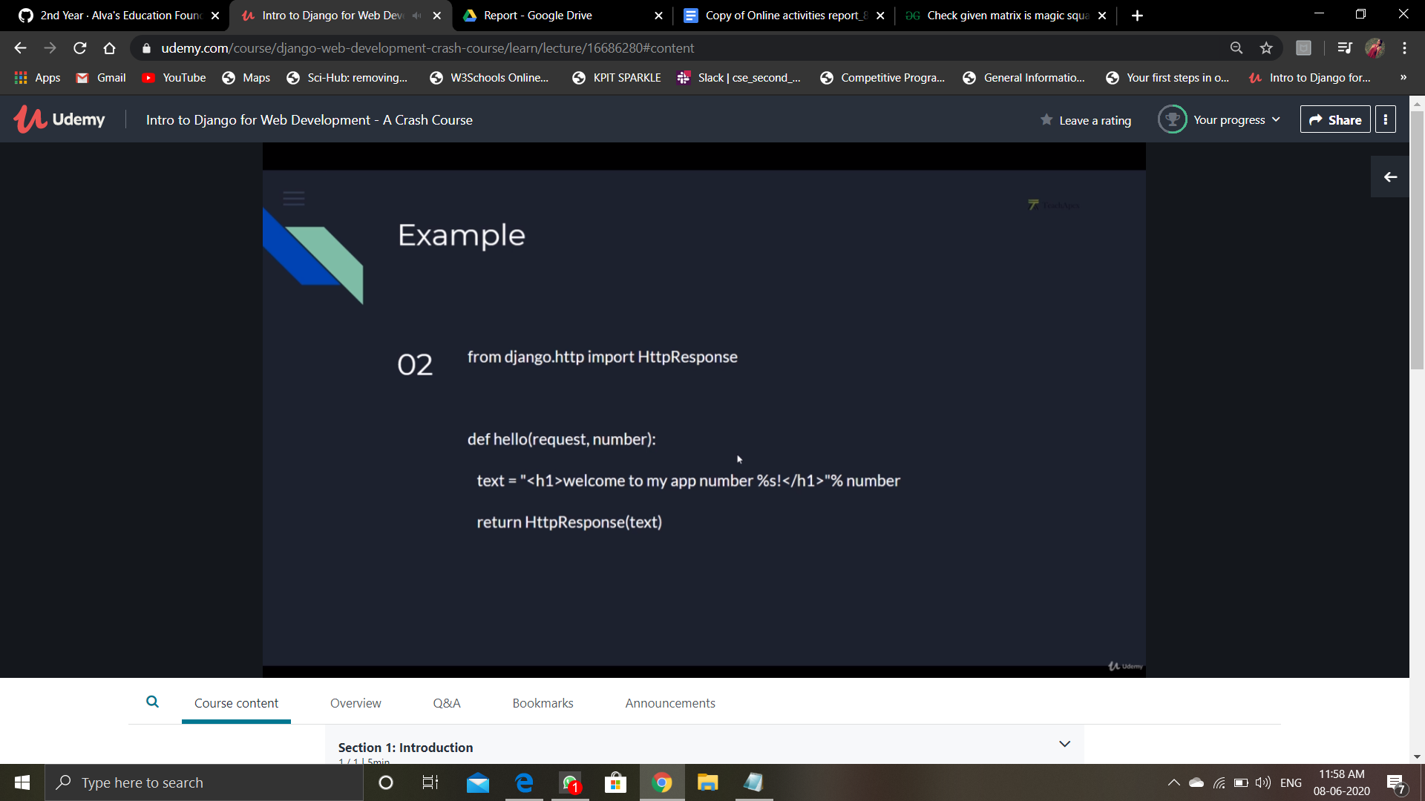

**Online Coding Summary:**

**Today I received one program from prof.Venkatesh CSE Dept and from prof.Shilpa CSE Dept, prof.Venkatesh CSE Dept. The program is mentioned above in the coding challenges(pg.01). I have also uploaded it to my Github repository.**

**The program is mentioned above in the coding challenges.I have written a program and uploaded it to my Github repository, as shown in the below.**

